Haunted Mansion

(A Survival Horror Game)

Design Document

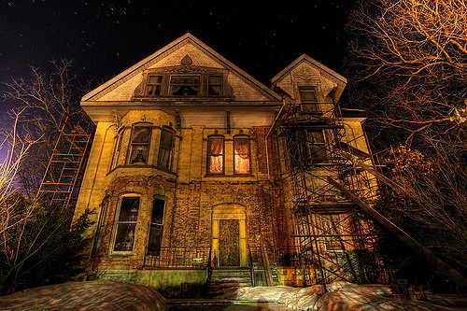

10/3/2017

By Andrew Letailleur & Kirstin Jackson

Paisley University, Students

Table of Contents

One Sentence Pitch 2

Main Concept 2

Flow Chart 2

Media Requirements 3

Visual Style 3

Colour Palliate 3

Audio Style 4

Media Sources 4

Storyboards/Concepts 5

Gameplay/Mechanics 5

Interaction 5

Control Schemes 6

Menus/GUI 6

Heads Up Display (HUD) 6

Player to Environment 7

Player to Enemies 7

Multiplayer (Player to Player) 7

Win/Lose Conditions 7

High Scores and Ranking 7

Level Design 7

Layouts 7

Progression 8

Player Progression 9

Missions/Objectives 9

Levelling Up/Power Ups/Perks 9

Difficulty/Power Downs/Debuffing 9

Bosses/Set Piece Events 9

Test Documentation 10

Test Plan for: Haunted Mansion 10

Test Table for Downtown Horror: EXAMPLE 10

References 17

Tools 17

Media 17

Appendix A *EXAMPLES, CHARACTERS / LAYOUT 19

Appendix B *EXAMPLES, LEVEL 20

City/Town ruins (Background sketches, top down) 21

Graveyard (Background sketches, top down) 22

Mansion (Background sketches, top down) 23

# One Sentence Pitch

Upon being trapped inside an abandoned mansion, the only way for escape is to avoid the past residents whom wish to claim your soul and the curse afflicted on the mansion by locating the key to the main entrance.

# Main Concept

According to local legend in a nearby village, there are rumors of a haunted mansion whose past residents were victims of a tragic fate. The local prince, of the era, inflicted a grave sin against a witch, whom in revenge, cursed not only the prince but the local residents of the town and any guests to suffer in an eternal purgatory instead of going into the afterlife. Thus, leading up to the mansion gaining it's infamous reputation for unexplained tragedies and the eventual decay the building suffered over years of not being maintained by residents whom in fear, had no interest in doing anything with the actual mansion or property it sat upon. This is how the mansion became an urban legend with the local community children, turning into a game where they dare friends to stay just one night within the boundaries of the haunted halls. If the friend makes it through the night, than this is seen as a badge of courage within their friend's eyes. Thus enter the protagonist, wanting to prove his bravery and daring to his mates, accepts said challenge. Only armed with his phone for light and a few small provisions, our protagonist enters the house to begin this challenge.

Only expecting the legend to be nothing more than a fictional myth created by his mates, the protagonist remains in the mansion overnight but awakes to find that the mansion is still cloaked within a shroud of darkness - indicting that it's still night time and the ghostly cries of those condemned to this place can be heard above him. In a panic, he tries to leave back through the entrance, only to find that the entrance has been locked prior to his entering. Thus, being trapped within a rumoured haunted mansion and the impending threat of the cursed residents chasing him, he will need to figure out a way to escape from the building, before the legend ends up killing him, cursing him to the same fate as the past residents - an eternal purgatory.

The overall general concept of the game borrows elements from the 'Haunted House' theme through horror and mystery while adding an 'Escape the Room' feeling to the gameplay by adding puzzle elements between the haunted atmosphere elements. There will be also be a 'Curse' mechanic where over a specific amount of time, the safety felt by the protagonist will be no longer and his health will start to be affected by growing number of wraiths. If the protagonist is unable to escape the mansion by sunrise, this will result in an automatic bad end.

# Flow Chart

Flowchart consists of the following table below, on the basic gameplay flow (with bias for the ‘Exit Game’ being from just the main menu, not taking into account the possibility of also coming from Instructions or either Ending Screens); **EXAMPLE**



# Media Requirements

Visual, Audio, est. Mention what assets would be required for the game at general?

**KIRSTIN**

# Visual Style

The visual style will primary be 2D in scale, as it can add more of a horror theme to it, on top of being easier for our team to create the required assets for in contrast to high quality 3D Assets, given the amount of time allotted to this project. This is especially true as in contrast to 2D tools, we’re far less experienced in quickly creating high quality 3D assets to meet the deadline.

* (WIP)

Close to an appeal of ’16-bit’, akin to old pokemon.  
  
This might be further complimented, with camera filter’s to at times, ‘kill’ the colour to be more ‘1-bit’ in scope, or through an old monitor. But

While the effects of any additional effects, (VISIAL STYLE, BE CLEAR. UTILIZE GAME ENGINE verb)

Lastly, the visual theme of the game should be akin to ___ (Read, describe Genre, like “Urban Fantasy”.)

## Colour Palliate

Dadada

██████ Example Color palette.

Keep in mind concepts like “Colour Blindness” (AVOID Red on Green at a minimum!) And contrast with the Colour Wheel (either Yellow on Purple, or for safety sake Yellow on Red/Blue, or Yellow on Orange/Green…)

Brightness contrast between light/bright colors, and dark colors. Actors should be bright, background should be dark. ?

# Audio Style

Sound wise, (describe audio, and possibly musical cues. Is there musical themes, is there sound effects? What would those sounds vary from, or musical genre?)

**KIRSTIN**

Don’t forget genre, (possible artist if quoting bias, like ‘Revolution Void’, and source, like Youtube or Newgrounds or Soundcloud.)

Commissioned Artist (site)

These sounds (audio) should ideally be outsourced through free sound archives such as **Freesounds.org** to save on development time. However, care should be taken to ensure issues don’t arise if and when the game generates income/profit due to the terms and conditions of the copyright legislation applied to the sounds. These concerns can be migrated to a degree if I instead create the sounds through recording audio in **Audacity**, and then editing it, to ensure there should be a legal source on the audio itself, within law. (Reword/expand, depending on context/sources. And possibility for sampling…)

# Media Sources

(Either handmade, or outsourced from free samples or hired artists?) If so, mention **Freesounds.org** and such as initial ‘sources’, along with possible instruments say…

***Sprite/Models List (2D/3D, ‘visual’ assets)***

|  |  |  |  |  |  |
| --- | --- | --- | --- | --- | --- |
| Asset ID | Date Created | Asset List | Asset Type | Sourced or Created | Status / Location |
|  | 27/01 |  |  |  |  |
|  |  |  |  |  |  |

***Music/Audio List (Sound assets)***

|  |  |  |  |  |  |
| --- | --- | --- | --- | --- | --- |
| Asset ID | Date Created | Asset List | Asset Type | Sourced or Created | Status / Location |
|  | 27/01 |  |  | “EX, This came from X guy, Copyright Status” |  |
|  |  |  |  |  |  |

***Script/Text List (Code assets)***

|  |  |  |  |  |  |
| --- | --- | --- | --- | --- | --- |
| Asset ID | Date Created | Asset List | Asset Type | Sourced or Created | Status / Location |
|  | 27/01 | Instructions text? | Text | Created |  |
|  |  |  |  |  |  |

# Storyboards/Concepts

***For all references to the illustrations of the concept art, see Appendix A.***

***Alternatively, for a better resolution of said assets, go to “Deviantart”***

The beginning area is …. Second area, is … And the last area, is …

Think of Ground Floor, First Floor, , and ‘outside’ as final area?

Each ‘stage’ (scene/map) should (Describe level feel/theme, possible repeating, and then describe gameplay rules, and exceptions to those gameplay rules.)

Past that, visual references for the overall style would ideally be based around the lines of (describe ‘visual inspirations’). Given the overall scope of the project however, I’d expect the game to be more akin to (Different ‘easier to render’ gameplay comparison)., or (simpler genre). in gameplay.

# Gameplay/Mechanics

## Interaction

Illustrate any necessary information relating to the players’ interaction with the game.

Interaction with Key, will enable the player to exit through the entrance on the ground floor, and cause a ‘trigger scene’ to happen in the first floor.

Door requires the player having a ‘key’ in inventory, before it can be opened/exited through.

Exit in courtyard for good ending, time out for time out, harmed by enemies upon touch. Run out of health, game over.

## Control Schemes

WASD, should move the player within a direction, from a top-down viewpoint. With W/S Keys moving the protagonist Up/Down, and the A/D keys moving the player Left/Right. Or Forward/Backward, Rotate Left/Right if going under a ‘control limitation’ horror.

F key activates the Flashlight, which will display light on the screen in order to possibly show, and/or slowly ward away the haunted residents. However, the flashlight can only be on for a limited time due to having a limited battery light. And without light being displayed, the residents will slow creep near towards the protagonist.

## Menus/GUI

When the game starts, a menu showing the title of the game, and the iconic building itself; the mansion, appears. The game will switch to the ‘gameplay’ scene once the player presses the ‘play’ button in the menu, and move to the ‘instructions’ scene if the player presses the ‘help’ button, which should then display the gameplay controls, a brief story on what you’re supposed to do in game, along with a prompt to return to the main menu, or otherwise play the game.

Upon starting the game, the player will be greeted with a menu which will show the title of the game and the iconic building, the mansion itself, appears. When the player presses the play button located within the main menu options, the game load upon the screen. Upon clicking the help button, the option will open the instructions screen which will insist of displaying the controls for gameplay, brief story arc on what the player is supposed to do within in the game as well as prompts to return back to the main menu or start the game.

Once the game starts, the player will go to the Gameplay Screen, consisting of the gameplay GUI containing a Health icon on the player’s current wellbeing, and the Clock, showing the amount of time the player has left. The camera view should be attached to the player’s position, especially when the player move throughout the stage.

As the game starts, the opening screen which consists of gameplay GUI, will load. The view of the camera will be attached to the position that the player is currently located at, this will move along with the player as they travel throughout the stage.

## Heads Up Display (HUD)

There should be two HUDS during gameplay; the player’s ‘health gauge’, and the game’s clock/timer.

The Health gauge should consist of a small ‘angled’ health bar that if emptied via harmful collision from enemies, will result in a game over. By default, this should be light blue if full, and black if empty, and possibly having the appearance of a ‘battery’ in a sense.

The clock/timer should show a watch, containing the position of the moon in the sky that acts as a timer. If the moon is at the left side, the game has just started, and the player has a lot of time with less danger to be aware of. However, if the moon is at the right side, then the player doesn’t have much time left, and a lot of enemies will spawn. If the moon goes past the right side and disappear from the display; then the player has earned a bad ending.

## Player to Environment

While interacting within the environment, the player will not have the ability to pass through set or spawned barriers such as walls and other blockades that are presented.

Other than that, the player can freely move within the environment that they can naturally pass through, unless it’s trying to move through another solid actor or enemy.

## Player to Enemies

Enemies should be visible to the player, especially if under the display of the Flashlight’s light. Otherwise, enemies should ideally be invisible when out of player ‘sight’.

Enemies, if left unseen or checked, will slowly drift towards the player, in spite of possible barriers to environment. And if they collide with the player unaware, they will disappear and take away a chunk of the player’s health. That said, if desired; the player can likewise go through more intangible enemies, at the same (if not smaller) cost to their own health as hazard.

-

movement behaviour, action behaviour in general. Note exceptions below general afterwards, such as changed visibility, say...

## Multiplayer (Player to Player)

Multiplayer mode will be not be applicable within this game since the play mode will only be for single player.

## Win/Lose Conditions

The player wins if they fully escape from the mansion, after sorting through all the puzzles and escaping fatal harm from enemies before time runs out. And lose/suffer from two possible bad ends, if they either lose all their health by enemy contact, or fail to escape from the mansion properly within the allotted time, by sunrise.

## High Scores and Ranking

Seeing this is a single player game, there would be no requirements for a hi-score board to be implemented within the game, this would only lead to a distraction from the gameplay. As for ranking, the overall feeling that the Player has managed to win the game or not would be the closest thing to this.

# Level Design

***For all references to the illustrations of the map layouts, see Appendix B.***

## Layouts

*Includes rough sketches of the background layouts, due to the nature of the game being a repetitive background.*

First ‘scene’ should be ground floor,

Second scene should be first floor, which contains a key.

Last scene should be the courtyard, (possible maze, one last wave of curses to bar escape.)

**EXAMPLE TEXT** - First stage should be with the theme of an ‘urban’ city, with buildings blocking off key areas, marking parts of the map in a corridor fashion. Second stage should be a bit more ‘open’ as a graveyard, but with tombstones scattered across the map that could be a persistent danger if not navigated right. And the last area should be more ‘staged’ as a manor, where the player would be more ‘boxed’ in in contrast to the more ‘open world’ gameplay supported initially. Above all else, the backgrounds should keep in mind consistency with looping through, in order to maintain an ‘illusion’ of free movement, without jarring edges making the fact the player is in a repeating ‘floor’, blatant.

## Progression

Progression is mainly made through solving puzzles barring progression of the game, going through the buildings in order to acquire keys to unlock additional rooms within the game, and eventually acquire the entrance key in order to escape through the mansion, and past the fields to freedom, while avoiding enemy contact whenever possible.

However, the player is under a time limit, as more time passes, the game becomes more dangerous for the player. In addition, if the player wastes too much time during the game, they will suffer from a different bad ending, under a “Time Out” cut-scene, where they suffer eternal torment by the curse.

(how can player go to next stage?). If (lose condition realized), the game will end in failure. However, should the player (pass through) every stage, then the player wins the game. (Possible last addition on score?)

**Path**

WIP Scope Notes.

Scene Scope.

G-Floor > 1-Floor (A > B) > G-Floor > Courtyard Escape

Local Scope

(LEVEL DESIGN)

(Path if linear, ‘routes’ if open world. Under where to be/go in order to trigger ‘main’ key scenes. Possible sub-scenes if going further detailed, est. AIM for simplicity whenever possible!)

Example…

*Even though the player is free to move anywhere within the game, the game itself is not a ‘true’ open world map with all the complexities thereof, because the game’s progression is based on how long the player is still alive. Gameplay wise, the player will go through three ‘stages’; City > Graveyard > Manor, before eventually receiving the victory if the player survives with some health throughout each stage. With the background and contents and layout of possible ‘barriers’ shifting throughout each stage. If the player were to die, or suffer a game over during each of the three stages, then the player will have to play from the beginning of the game again. This might be a bit painful for the player, but I feel it’d be a vital pain to add some emphasis on surviving through the limited amount of content within the game itself, under a “Nintendo Hard” style philosophy of game design.*

**Difficulty**

The only challenges the player should face, would be from possible barriers that the player cannot move pass, gates the player pass through without having collected a ‘key’, the amount of time they have left before a bad end is triggered (which is shown through the timer HUD), along with the danger of injury posed by the enemies themselves, who will gradually become more common in sight/danger the longer the game itself runs.

# Player Progression

## Missions/Objectives

The main objective, is to escape the mansion, through the entrance, or another exit route. This is done through exploring the mansion, for any possible pickups, or interactive objects in order to trigger change within the locked landscape.

**WIP** (CONDITION TO PROGRESS, AND HOW PLAYER CAN ACHIEVE THAT OBJECTIVE)

## Levelling Up/Power Ups/Perks

If possible, a ‘refill’ on battery charges being available for flashlight.

No power ups, perks or pick-ups are planned to be available throughout the game. What the protagonist has initially, has to last through the entire playthrough.

Includes ‘Pick ups’, boosts upon a set criteria, est. Either external (pick up), or internal (triggered.)

## Difficulty/Power Downs/Debuffing

Potential debuffs, external ‘power down’ pick ups, or internal ‘fatique’ or status effect say. Also include potential of enemy spawn ratio to affect difficulty, depending on position/area, and difference of AI, in a ‘margin of error’ sort of fallacy, including possible ‘barriers’ or traps physically?

## Bosses/Set Piece Events

The set pieces, event wise would consist of three things; read, not random places, likely ‘trigger scenes’ or boss beings. Example;

* *The background along with any walls that are bound to the background*
* *the enemy spawn frequency being capped ensure the game screen is not overwhelmed by hazards.*
* *And the ‘to next stage’ condition, that is timer bound to determine how long each stage lasts.*

The main ‘boss’ of the game, would be (BOSS Entity/name, general AI move set, removal conditions, and where it’d spawn.)

(THEN, Stages, and spawn variables, stage barriers, key events to change barriers/obstacles, and possible progression routes. And mention if any stage can spawn a ‘Boss’, along any additional wishes for ‘tertiary’ game features.)

Once the player has (achieved progression trigger in) each stage, the player has won the game. Otherwise, if the player (Triggers loss condition) at any time, they lose the game.

This is all, subject to change, depending on difficulties encountered during development in programming, and deadlines that can limit the scope of the project. But at a minimum, there should be at least (MIN) stages in gameplay, with at least (Absolute key features depending on brief.)

# Test Documentation

## Test Plan for: Haunted Mansion

In general, this Test Table was created under the general path/logic of Top Down testing, and the mentality of Black Box conditions. Each step is delivered through Thread Testing to ensure that each test is done in ‘steps’, so that the results of each step are recorded as they are assessed.

This test table is only designed to test the controls, the gameplay, and the menu transitions.

# Test Table for Downtown Horror: EXAMPLE

|  |  |  |  |  |  |
| --- | --- | --- | --- | --- | --- |
| Test Case ID | Test Action/Description | Expected Result/Output | Actual Result/Output | Test Pass/ Fail | Action Taken |
|  | Ensure the app properly loads the Unity Title when the app/program itself starts, Unity wise. | That the app loads properly without crashing, and the splash screen is loaded. | -**Start up Menu** |  |  |
|  | Check the “Main Menu” page loads properly once the Unity logo disappears. | That once a few seconds have past, the main screen will load along with two buttons, for playing the game, and help. |  |  |  |
|  | Check that if the user presses the ‘back button’, the app will instead close itself. | That if the back button is pressed, the app will close itself (ideally.) |  |  |  |
|  | Check that the user can access the “instructions” screen from the “Main Menu” screen, by pressing the help button. | That the help screen itself loads over the main menu, and shows a scaling set of instructions, along with a “Return” button to go back to the main menu, and a “play game” button to start the game itself. |  |  |  |
|  | Check that the text from the instructions page itself is scalable, and above all else readable on a mobile device. | That the text itself will faithfully scale to whatever native resolution the user’s mobile has, and above all is, is readable. |  |  |  |
|  | Check that the user can go back to the “main menu” page from the “help” page, by pressing the return button. | That the main menu loads over the previous page, and shows the main menu screen along with two buttons, play game and instructions. |  |  |  |
|  | Check that the user can play the game from the “main menu” page, by pressing the “Play Game” button. | That the gameplay screen loads over the main menu, and starts the gameplay with the player character in the center, and a full health bar. |  |  |  |
|  | Check that the user can play the game from the “instructions” page, by pressing the “Play Game” button. | That the gameplay screen loads over the help screen, and starts the gameplay with the player character in the center, and a full health bar. |  |  |  |
|  | Check to ensure that gameplay levels are loading correctly when required in game. | That level design, assets and such are loading properly without game crashing bugs, especially during stage progression. | -**Gameplay** |  |  |
|  | Check to ensure the player initially spawns at start with a full health bar. | That when the game starts, the health bar is rated ‘full’ when the player character has been spawned. |  |  |  |
|  | Check to ensure the player can move their avatar to where the player tapped the screen, with a red dot showing where they’d move to. | That upon touching any area within the screen, a red dot will appear where the player tapped, and the avatar will face and move towards that red dot. | -**MOVEMENT** |  |  |
|  | Check to ensure map is scrolling, or looping no matter how far or where the player goes/moves to. | That if the player moves vertically long enough, the map will loop vertically, likewise if horizontally. |  |  |  |
|  | Check to ensure the camera always follows the player, and is always centered at player location. | That the screen will always follow wherever the player moves towards, and that the player is always center to the camera screen. |  |  |  |
|  | Check to ensure there can never be more than a set amount of enemies in the game screen, depending on the stage the player is in. | That there won’t spawn more than a set amount of enemies on screen, with the cap increasing according to the stage number. | **Enemy Spawn** |  |  |
|  | Check to ensure that enemies spawn in a random side of the screen, upon being spawned. | That if an enemy appears, they can appear from any side of the game screen itself. |  |  |  |
|  | Check to ensure zombies spawn at all stages, ghouls at the second and third stages, and the vampire at the last stage itself. | That zombies appear in all game levels, ghouls from the second level onwards, and the vampire at the last stage/level. |  |  |  |
|  | Check to ensure the enemy emits a sound depending on what type of enemy they are upon spawning. | That when an enemy appears on screen, they will emit a sound that will tell the player what kind of enemy they are. | **Enemy movement** |  |  |
|  | Check to ensure that each type of enemy is easy to spot, by visual color and set animation alone. | That each enemy has a unique ‘color’, and animation assigned to it. With the sole exception of Vampire, that has no ‘animation’ so to speak of. |  |  |  |
|  | Check to ensure that the zombie and ghoul monsters move at a set direction at all times when spawned, unless their rotation has been ‘nudged’. | That the zombies and ghouls, will always move at a set ‘pace’ in a linear direction, acting as visual ‘bullets’ or obstacles the player must move through or dodge. |  |  |  |
|  | Check to ensure the vampire always circle or ‘strife’ around the player, and slowly move towards the position of the player. | That the vampire will always circle around and face the player themselves, while slowly moving towards the player over time. |  |  |  |
|  | Check to ensure that a Ghoul or Vampire can fire a shot in front of them. | That the vampire and ghoul will always fire a shot moving in the direction they were facing at the time. |  |  |  |
|  | Check to ensure the bullet will travel towards it’s set direction, once spawned/fired. | That once fired, a bullet will constantly travel according to its parent’s aim, until collision with other actors or player. |  |  |  |
|  | Check to ensure bullet disappears from game after a set amount of time, or upon collision of player. | That the bullet will disappear after a set amount of time, or if it hits the player themselves. |  |  |  |
|  | Check to ensure the player loses health over time if they are in contact with any enemy unit collision wise. | That as long as the player is in ‘touch’ contact with any enemy, they will slowly lose their health over time. | -**Collision** |  |  |
|  | Check to ensure that the player loses a chunk of health if hit by a projectile, before the bullet disappears from the game itself. | That if a player collides with a bullet, they will lose a visible percentage of their health, before the bullet will disappear. |  |  |  |
|  | Check to see that enemies can’t go through each other, nor move past the player themselves. | That as intended, the enemies can’t move over each other or the player. |  |  |  |
|  | Check to see if a zombie or ghoul is out of the game screen after a set amount of time, they will disappear from the game itself. | That if a zombie or ghoul is out of the screen for more than a few seconds, they will remove themselves from play, and decrease the total amount of enemies for spawning count purposes. |  |  |  |
|  | Check to see that if player loses all health, the game will move to a game over screen. | That upon losing all health, the player will go to a ‘game over’ page along with two buttons, for playing the game again, and return to the main menu. | -**Progression** |  |  |
|  | Check to ensure gameplay moves to a new stage, after a set amount of time. | That upon not dying/losing all health for a set amount of time, the player will automatically move to the next ‘stage’, visually. |  |  |  |
|  | Check to ensure player goes to the ‘ending’ screen if they survive all three levels of gameplay. | That upon surviving for a set amount of time for all three stages, the player will go to the ending screen, having ‘won’ the game. |  |  |  |
|  | Check that the user can play the game again from the “Game Over” screen, by pressing the play again button. | That the gameplay screen loads over the game over screen, and restarts the gameplay with the player character in the center, and a full health bar. | -**After Game HUD** |  |  |
|  | Check that the user can go back to the “main menu” page from the “Game Over” page, by pressing the return button. | That the main menu loads over the previous page, and shows the main menu screen along with two buttons, play game and instructions. |  |  |  |
|  | Check that the user can play the game again from the “Ending” screen, by pressing the play again button. | That the gameplay screen loads over the ending screen, and restarts the gameplay with the player character in the center, and a full health bar. |  |  |  |
|  | Check that the user can go back to the “main menu” page from the “Ending” page, by pressing the return button. | That the main menu loads over the previous page, and shows the main menu screen along with two buttons, play game and instructions. |  |  |  |

# References

The list of media and tools referenced during this document are. (Update as/when required)

## Tools

**Unity**, and by proxy the Unity Assets available on the Unity Store, is a definite inclusion in order to develop the game and acquire the 3D rendered assets not available easily. In addition, some assets have been given from the client for use in the development of the game.

**Maya,** due to… (UNIVERSITY REQUIREMENT!?) ?

**Audacity**, as it’s an excellent free, open source software tool great for recording, editing and recreating sounds for different file formats.

**Freesounds.org**, as it’s a bank of free sounds that can be a useful aid in creating atmosphere for the game, without having to put effort in making the sounds through recording and audio software.

**GIMP** (Kirstin preference.)

**Paint.net**, or other software. Due to being a more focused 2D image toolkit, and free as well. IF I were able to access/utilize a more advanced image creation/editing software, such as…

**Photoshop (latest, non-cloud based version)**, By far, the most industry software for image creation I can recall. However, it’s cost or required subscription for use, and complexity behind some of the tools, can take some time to get used to. But the flexibility it offer’s is in stark contrast to free open source projects. (Consider REDACTING any potential references to ‘non-cloud’.)

## Media

**Videogame/Genre** references (As in, ‘Media inspirations’, such as ‘Harry Potter’, or Metal Gear…)

**Resident Evil**

Manor theme, with haunted enemies, or in this case Zombies. Is apparently gotten spiritual influence from a far earlier game called “Sweet Home”, with haunted enemies and traps included.

**Escape the Room (Genre)**

Under Puzzle games, Browser Game genre wise. In this case, it’s more of a convention I’m thinking of, where the player has to interact with the environment, in order to acquire keys or trigger scenes that enable progression to the next ‘room’, or level, or beating the game.

**Chip’s Challenge**

Nostalgia, on a puzzle game,

One where you have to solve puzzles to get the keys in order to get to the next level, while avoiding enemies. (And similar in idea to the proposed tone.)

WIPPY

**Beauty and the Beast (Story)**

More in the rough concept of the “Prince”, being more of a “Beast” cast into a curse, sort of archetype. Yet unlike the Disney version, where he’s cursed by a rose, and there’s a “Happily ever after” attached to it by some sudden offended fairy, it’s a matter of a ‘beast wraith’ monster, that might chase after the player at the end game, in wraith. Bonus points if the “Prince” was in a courtyard, and can act as a sort of “Minotaur in a Labyrinth” sort of tone/archetype.

-

Mouse Hunt/Trap (Run away from cats),

**Silent Hill**

Mainly under a feel of a sort of ‘otherworldly’ feel, over that of psychological horror, given the scope of the project. Though later on, an emphasis on psychological horror might be a possible avenue to make the game more scary, without relying overly on jump scare logic.

**Spooky’s Jumpscare Mansion**

In the sense of an interactive ‘traverse rooms’ sort of vibe, with occasional ‘keys’, and having to run away from a pursuing enemy at times. And also on the scale of jump scares, easy cliché wise.

**“Unknown PlayJam Horror Game”**

Can’t give a reasonable reference past pure memory alone, but I *knew* this game existed at some point, until a lack on archiving on TV “Pay to Play” Games lead to a *lack* of knowledge on this game. Point is, all I know is that it was a sort of TV ‘survival horror game’, set within a Japanese School, and that the protagonist had to escape the haunted school full of youkai before sunrise, or she’d never be able to leave. Would have known more on the game, but as it was under a paywall at the time, I wasn’t able to go past the tutorial, and wait for the ‘time out’ screen.

Walking Dead?

Witches House, Mad Father, Ib. (Indie Horror Game examples.)

Until Dawn

# Appendix A *EXAMPLES, CHARACTERS / LAYOUT

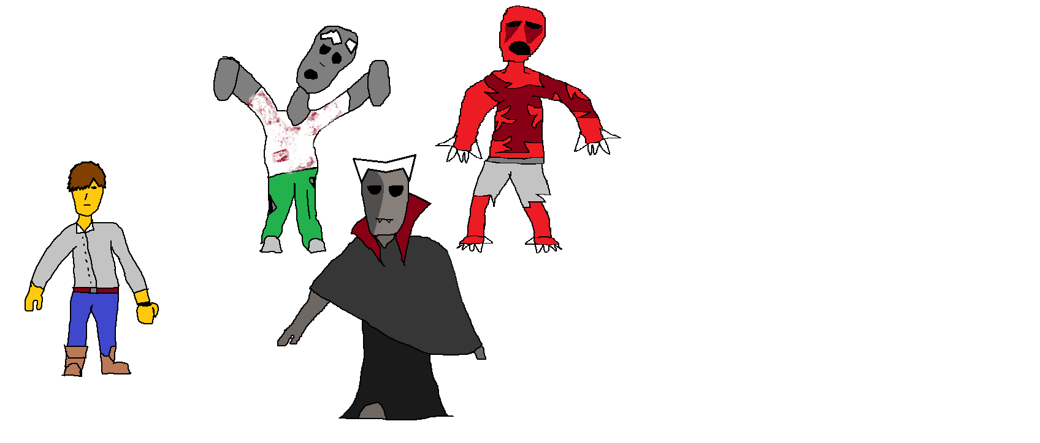

Rough concept sketch of protagonist (left), and the three key threats (enemies, Zombie, Ghoul, Vampire.

|  |  |  |  |
| --- | --- | --- | --- |
| PIC LEV 1;  Ground Floor | PIC LEV 2;  First Floor | PIC LEV 3;  Courtyard | **Gameplay Events** |
| If Player touches any hazard; **Decrease current Health**  If health reaches zero; **Clear all actors, and go to ‘Game Over’ screen.**  If timer reaches zero; **Clear all actors, and go to ‘Time Out’ screen.**  If Player reaches exit; **Clear all actors, and go to ‘Escape End’ screen.**  **Gameplay time should roughly consist of 30 minutes at most, at a push. With a ‘soft’ cap being 20/25 minutes until peak difficulty.** |
| Description | Description | Description |
| PIC TITLE | PIC GAME OVER | PIC TIME OUT |
| Description | Description | Description |
| PIC Cut-Scene A | PIC Cut-Scene A | PIC ESCAPE END |
| Description | Description | Description |

Rough sketch for the gameplay layout, in gameplay and stage theme, without going into detail on possible obstacles.

# Appendix B *EXAMPLES, LEVEL

***Ground Floor***

**\*IMG\***

each ‘image’, map wise.

***First Floor***

**\*IMG\***

each ‘image’, map wise.

There should be a few barrier’s to each floor, and only by unlocking/gaining persisting ‘keys’, can the player progress. Until eventually reaching the exit, located at the ground floor.

***Courtyard***

**\*IMG\***

The last ‘level’, where the player will have to escape the ‘garden’ of the mansion, before the game is finished. Might contain one last wave of enemies, or a differing ‘clock’ featuring a Bloodmoon instead. Before the player either dies, or gets the Escape ending.

EXAMPLES BELOW!

## City/Town ruins (Background sketches, top down)

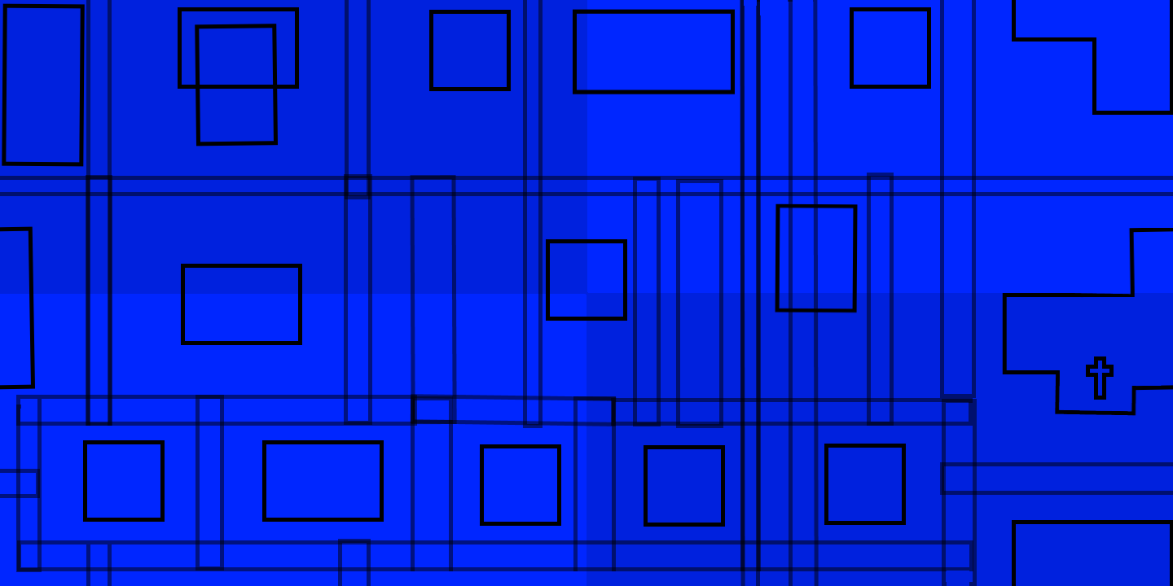

A sequence of four images, that should loop endlessly within the gameplay as the player moves past each ‘image’, map wise.

This is, a ‘rough’ prototype of the city stage. As given enough I might be able to fine tune the placement of buildings, and even include a sort of ‘top down 3D effect’ with the buildings themselves, that could become an additional obstacle in movement.

Key theme should enable endless ‘movement’ vertical and horizontally, with the potential for minor buildings here/there acting as barriers to movement, depending on timeframe.

## Graveyard (Background sketches, top down)

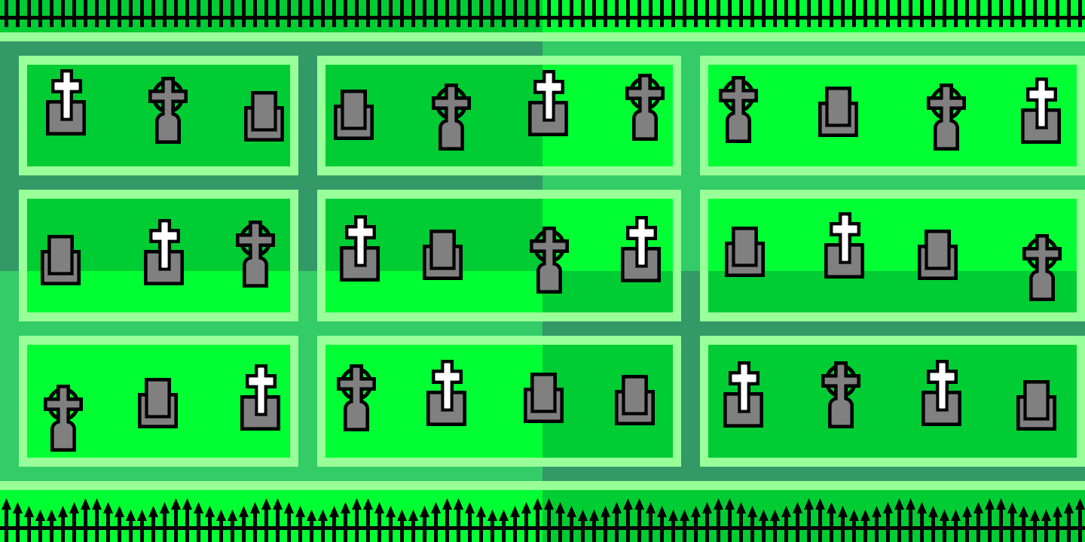 A sequence of four images, that should loop endlessly within the gameplay as the player moves past each ‘image’, map wise.

This is, a ‘rough’ prototype of the graveyard stage, with image placeholders along with some artwork of a fence in play/hand. Given enough time, I might be able to fine tune the placement of tombstones as obstacles, and even include a sort of ‘top down 3D effect’ with the tombs and fences themselves, that could become an additional obstacle in movement.

Key gameplay theme should be if given time, enable endless ‘movement’ horizontally, with the fence acting as a barrier to vertical movement, and along with the tombstones themselves, depending on timeframe.

However, if pushed for time, same movement restrictions as the first level would do.

## Mansion (Background sketches, top down)

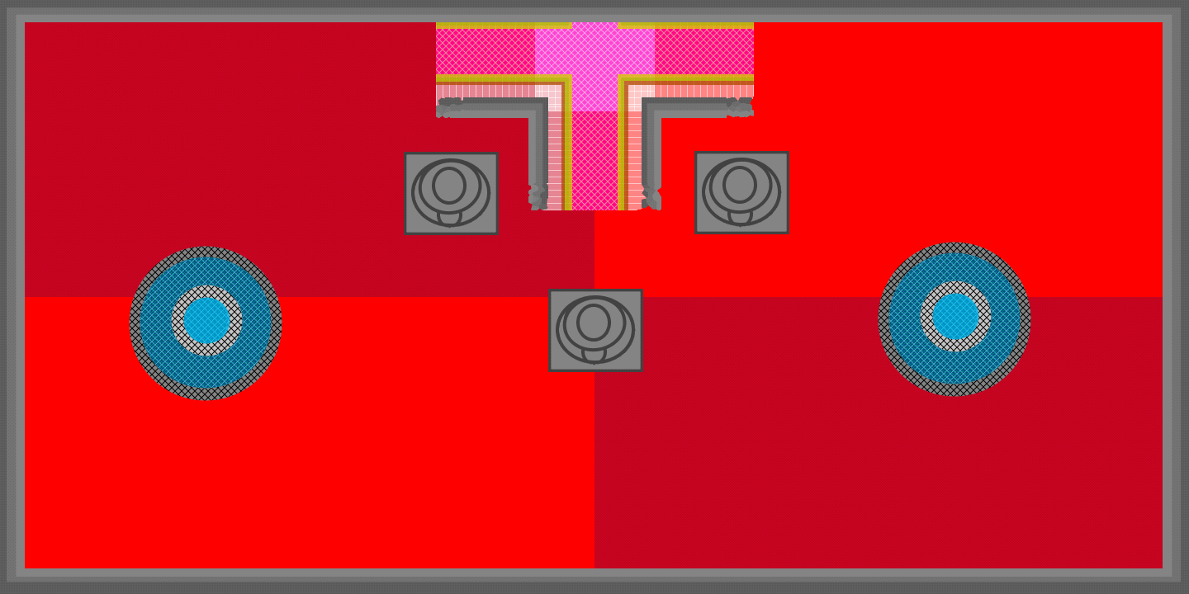

A sequence of four images, that should loop endlessly within the gameplay as the player moves past each ‘image’, map wise. Unless barriers are taken into account, ‘scene’ wise.

This is, a ‘rough’ prototype of the manor stage, with image placeholders along with some artwork of the walls/’hallway’ in play/hand. Given enough time, I might be able to fine tune the placement of stairs and fountains as obstacles, and even include a sort of ‘top down 3D effect’ with the objects themselves, that could become an additional obstacle in movement.

Key gameplay theme should be if given time, be of a more ‘restricted’ closed world for a change, due to being stuck in a manor with walls enclosed, barring movement past a closed space, depending on timeframe. If I am unable to fully implement such ‘obstacles’ in time however, it will instead have to default to a more ‘open world’ layout, and be more akin to a fudged ‘endless manor’.

However, if pushed for time, same movement restrictions as the first level would do.